|  |  |
| --- | --- |
| **Exp No: 7**  **Date: 19.04.25** | servlet program to store using cookies |

**AIM :**

Write a Servlet program to store a user's preferences (like theme or language) using cookies. Retrieve and display these preferences on subsequent visits.

**PROGRAM:**

**COOKIE.HTML**

<!DOCTYPE html>

<html>

<head>

<meta charset=*"ISO-8859-1"*>

<title>Cookie</title>

</head>

<body>

<form method=*"post"* action=*"/ROHIT_1916/Cookies"*>

<p>

<label>Theme: </label>

<input type=*"text"* name=*"Theme"*>

</p>

<p>

<label>Language: </label>

<select name=*"language"*>

<option value=*"English"*>English</option>

<option value=*"Tamil"*>Tamil</option>

<option value=*"Hindi"*>Hindi</option>

</select>

</p>

<button type=*"submit"*>Save Preferences</button>

</form>

</body>

</html>

GETCOOKIE.jsp

<!DOCTYPE html>

<html>

<head>

<meta charset=*"ISO-8859-1"*>

<title>GET COOKIE </title>

</head>

<body>

<%

Cookie[] cookies = request.getCookies();

**if** (cookies != **null**) {

**for** (Cookie cookie : cookies) {

**if** ("Theme".equals(cookie.getName())) {

System.out.println(cookie.getName());

out.println(cookie.getValue());

}

**else** **if** ("language".equals(cookie.getName())) {

System.out.println(cookie.getName());

out.println(cookie.getValue());

}

}

}

%>

</body>

</html>

**Cookie.java**

package com.rohit.servlet;

import java.io.IOException;

import javax.servlet.ServletException;

import javax.servlet.annotation.WebServlet;

import javax.servlet.http.Cookie;

import javax.servlet.http.HttpServlet;

import javax.servlet.http.HttpServletRequest;

import javax.servlet.http.HttpServletResponse;

/**

* Servlet implementation class Cookies

*/

@WebServlet("/Cookies")

public class Cookies extends HttpServlet {

private static final long serialVersionUID = 1L;

/**

* @see HttpServlet#HttpServlet()

*/

public Cookies() {

super();

// TODO Auto-generated constructor stub

}

/**

* @see HttpServlet#doGet(HttpServletRequest request, HttpServletResponse response)

*/

protected void doGet(HttpServletRequest request, HttpServletResponse response) throws ServletException, IOException {

String theme = request.getParameter("Theme");

String lang = request.getParameter("language");

Cookie theme_cookie = new Cookie("theme", theme);

Cookie land_cookie = new Cookie("language", lang);

theme_cookie.setMaxAge(60*60);

land_cookie.setMaxAge(60*60);

theme_cookie.setPath("/");

land_cookie.setPath("/");

response.addCookie(theme_cookie);

response.addCookie(land_cookie);

response.sendRedirect("getcookie.jsp");

}

/**

* @see HttpServlet#doPost(HttpServletRequest request, HttpServletResponse response)

*/

protected void doPost(HttpServletRequest request, HttpServletResponse response) throws ServletException, IOException {

// TODO Auto-generated method stub

doGet(request, response);

}

}

**OUTPUT:**

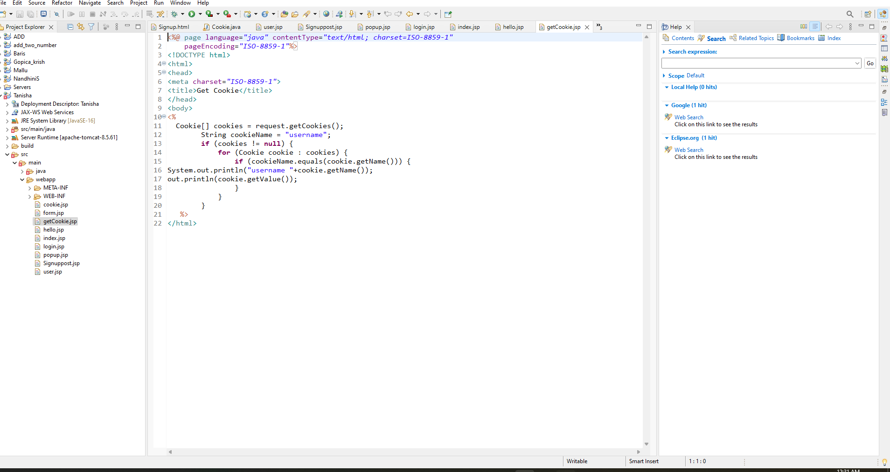

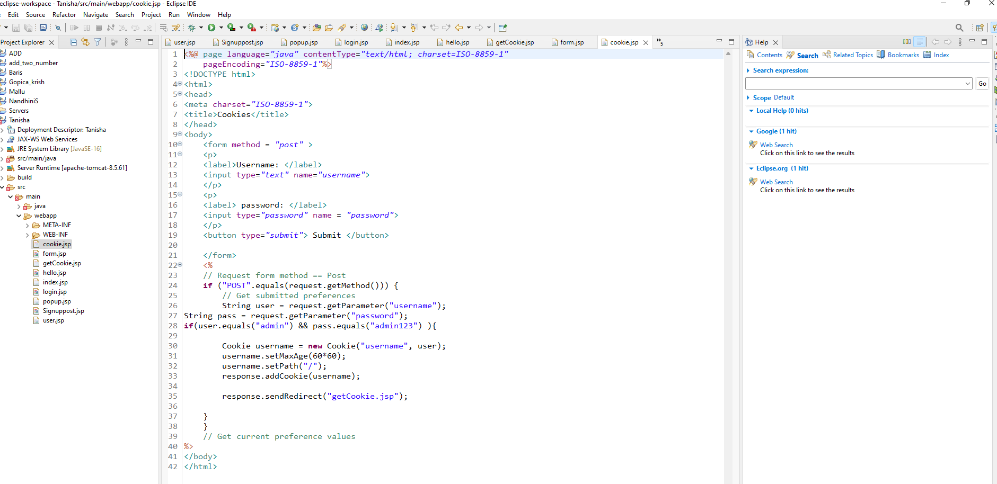

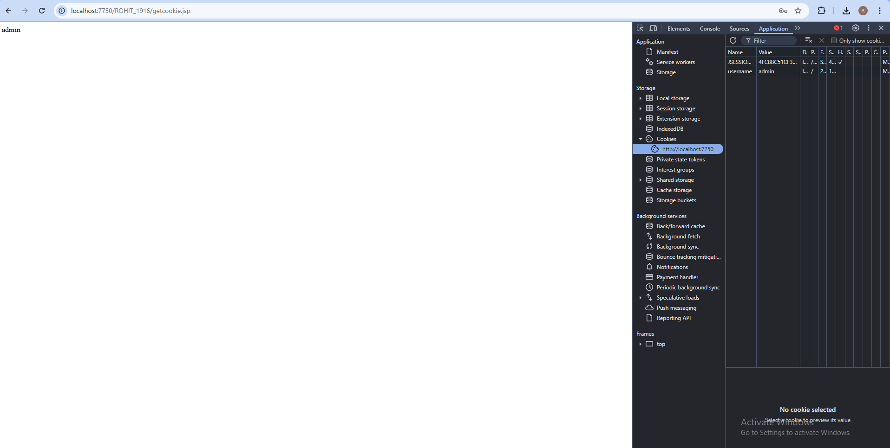

**RESULT :**Thus the experiment Write a Servlet program to store a user's preferences (like theme or language) using cookies. Retrieve and display these preferences on subsequent visits has been successfully implemented and verified